**SC2006 Software Engineering**



**Lab#4 Deliverables**

Lab Group A29

Group Name: Mala

Lab Supervisor: Dr Liu Yang

| Group Members | |
| --- | --- |
| Name | Matriculation No. |
| Pavanraj Selvaraju | U2122616H |
| Ng Yao Ming | U2122168F |
| Low Yong Keng | U2122645L |
| Teo Kai Jie Keith | U2121074G |
| Oak Soe Khant | U2121901K |

**Table of Contents**

**1.0 Source Code 3**

**2.0 Test Cases 4**

2.1.1 Black Box Testing 4

2.1.2 Black Box Testing (Searcher Set Up Page) 5

2.2 White Box Testing 6

2.2.1 Sign Up White Box Testing 7

2.2.2 getJobs White Box Testing 9

**3.0 Demo Script 10**

3. JobQuest DemoScript 10

# 1.0 Source Code

Kindly refer to link to see full source code:

<https://github.com/KayTeo/JobQuest/tree/main/jobquest>

# 

# 2.0 Test Cases

## 2.1.1 Black Box Testing

Black Box testing is used to test equivalences classes and boundary value testing.

Test Case 1: Creating Account

Checking if all the user details that a user inputs is valid before signing the user up and creating a new account in the database.

| Email | Username | Password | Confirm Password | Expected Output | Actual Output (Log == Oracle) |
| --- | --- | --- | --- | --- | --- |
| Empty | Keith | Password1! | Password1! | Display “Please enter a valid email.” | Pass |
| [KTEO024@e.ntu.edu.sg](mailto:KTEO024@e.ntu.edu.sg) (Assuming email not yet used for sign up) | Empty | Password1! | Password1! | Display “Username cannot be empty.” | Pass |
| [KTEO024@e.ntu.edu.sg](mailto:KTEO024@e.ntu.edu.sg) (Assuming email not yet used for sign up) | Keith | Empty | Password1! | Display “Password should be minimum 8 characters, containing at least 1 letter, number and special character.” | Pass |
| [KTEO024@e.ntu.edu.sg](mailto:KTEO024@e.ntu.edu.sg) (Assuming email not yet used for sign up) | Keith | Password1! | Empty | Display “Two passwords do not match.” | Pass |
| [KTEO024@e.ntu.edu.sg](mailto:KTEO024@e.ntu.edu.sg) (Assuming email not yet used for sign up) | Keith | Password1! | Password2! | Display “Two passwords do not match.” | Pass |
| [KTEO024@e.ntu.edu.sg](mailto:KTEO024@e.ntu.edu.sg) (Assuming email not yet used for sign up) | Keith | Password1! | Password1! | User redirected to home page. | Pass |

## 2.1.2 Black Box Testing (Searcher Set Up Page)

## Test Case 2: Searcher Set Up Page

Checking searcher setup details are valid.

| School | Major | Location | jobType | Citizenship | Skills | Expected Output | Manual Unit Test Results |
| --- | --- | --- | --- | --- | --- | --- | --- |
| Empty | Computer Engineering | West | Internship | Singaporean | [“Java”, “C”] | Display “Please fill out this field” | Pass |
| National University of Singapore | Empty | East | Full-Time | PR | [] | Display “Please fill out this field” | Pass |
| Nanyang Technological University | Computer Science | Empty | Part-Time | Others | [“Public Speaking”] | Display “Please fill out this field” | Pass |
| Singapore Management University | Business | South | Empty | Singaporean | [“C”, “C++”, “C#”] | Display “Please fill out this field” | Pass |
| Singapore Management University | Economics | North | Contract | Empty | [“Teamwork”] | Display “Please fill out this field | Pass |
| Singapore University of Technology and Design | Chinese | Central | Part-Time | Singaporean | Empty | Display “Please fill out this field | Pass |
| Singapore University of Technology and Design | Chinese | Central | Part-Time | Singaporean | [“”] | Does not allow skill to be added. | Pass |
| Singapore University of Technology and Design | Chinese | Central | Part-Time | Singaporean | [“ “] | Does not allow skill to be added. | Pass |
| Singapore Management University | Chinese | Central | Part-Time | Singaporean | [“ “] | Does not allow skill to be added. | Pass |

## 

## 

## 2.2 White Box Testing

White box testing was done to ensure that the flow of our application is correct as well as to check for alternative flows in our application.

## 2.2.1 Sign Up White Box Testing

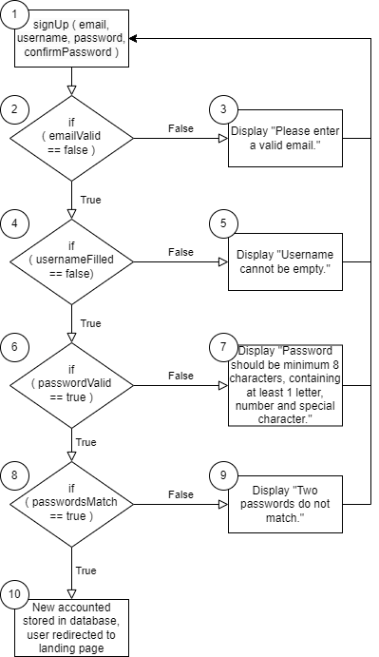

Test Cases:

1. User creates an account with email not taken, username not taken, password meets requirements and both passwords match.

Execution path: 1, 2, 4, 6, 8, 10

1. User creates an account with email taken, username not taken, password meets requirements and both passwords match.

Execution path: 1, 2, 3

1. User creates an account with email not taken, username taken, password meets requirements and both passwords match.

Execution path: 1, 2, 4, 5

1. User creates an account with email taken, username not taken, password does not meet requirements and both passwords match.

Execution path: 1, 2, 4, 6, 7

1. User creates an account with email not taken, username not taken, password meets requirements and both passwords do not match.

Execution path: 1, 2, 4, 6, 8, 9

Cyclomatic Complexity:

[Edges - Nodes] + 2 = [9 - 6] + 2 = 3

[Conditions] + 1 = 4 + 1 = 5

## 2.2.2 getJobs White Box Testing

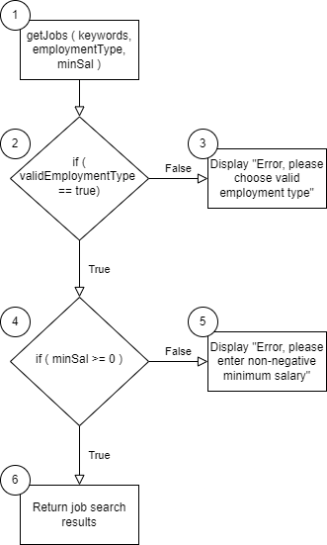

Test Cases:

1. User sends job request with keywords, valid employment type and non-negative minimum salary.

Execution path: 1, 2, 4, 6

1. User sends job request with keywords, invalid employment type and non-negative minimum salary.

Execution path: 1, 2, 3

1. User sends job request with keywords, valid employment type and negative minimum salary.

Execution path: 1, 2, 4, 5

Cyclomatic Complexity:

[Edges - Nodes] + 2 = [5 - 4] + 2 = 3

[Conditions] + 1 = 2 + 1 = 3

# 3.0 Demo Script

## 3. JobQuest DemoScript

Hello and welcome to JobQuest, the ultimate job tracking and finding application. With JobQuest, you can easily keep track of all your job applications, find new job opportunities, boost your resume and connect with others in the job search community. Today, I'm going to give you a demonstration of the app's key features.

SIGNING UP AND LOGGING IN:

To get started with JobQuest, you can sign up with an existing Google account or with your email. If you choose to sign up with your email, you'll be asked to provide some basic information, such as your username and a default profile picture will be allocated to you. If you choose to sign up with your Google account, your username and profile picture will be aligned with your Google account. Once you've created your account, you can log in and start exploring the app.

TRACKING YOUR JOB APPLICATIONS:

One of the most useful features of JobQuest is the ability to track your job applications. To do this, simply click on the "Applications" tab. Here, you'll see a list of all the jobs you've applied for, along with their current status. You can update the status of each application as you move through the hiring process, from "Applied" to "Interview Scheduled" to "Offer Received" and beyond.

FINDING NEW JOBS:

Of course, JobQuest isn't just about tracking your existing applications. We also want to help you search for new job opportunities. To do this, click on the "Searcher" tab. Here, you'll see a list of job postings that match your user job profile and search terms. You can filter in a number of ways, including minimum salary and employment type. When you find a job that interests you, simply click on it to learn more and apply. You can also add it to your “Wishlist”, a list of jobs that you are watching but have not applied to yet.

RESUME BOOSTER:

After choosing the jobs you wished to apply for, you can go to the booster page where you can enter the fields so that the application is able to craft a resume based on your skills and knowledge that will best suit for the job. Furthermore, it will also create a cover letter for you to apply for the job that you want.

JOINING THE JOB SEARCH COMMUNITY:

Finally, JobQuest has a forum where you can connect with others in the job search community. To access the forum, click on the "Forum" tab. Here, you'll be able to start and join discussions by making posts about job search strategies, resume tips, interview techniques, and more. You can also ask questions and get advice from other members of the community when they comment on your posts.

CONCLUSION:

Thank you for taking the time to learn about JobQuest. We believe our app is the best tool for tracking and finding jobs, and we hope you'll give it a try. Sign up today and see how easy it can be to take control of your job search!